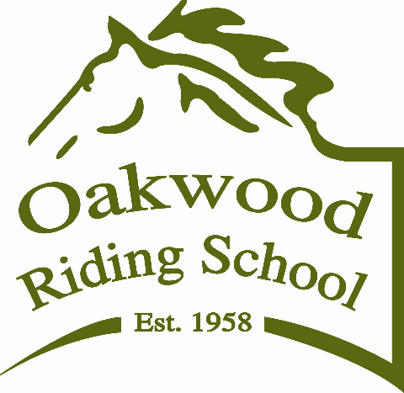

THE HONORARY SECRETARY

OAKWOOD RIDING SCHOOL

I desire to become a member of the OAKWOOD RIDING SCHOOL and I agree if admitted to membership to be bound by the MEMORANDUM and ARTICLES of ASSOCIATION of the school and the RULES OF ORS.

FULL NAME OF APPLICANT…………………………………………………

ADDRESS………………………………………………………………………..

…………………………………………………… POSTCODE…………….

MOBILE:……………………………

EMAIL……………………………………

DATED this ……………………….day of …………………………… 20…

CATEGORY (tick your category which are detailed on Membership information document)

Full $400 per annum

Family $450 per annum (all members covered are to be listed)

Student/Agistee $300 per annum

Junior $250 per annum

Non Riding $100 per annum

Half yearly pro rate membership is available on application.

If you have any special skills or talents that may be helpful to Oakwood, and you are willing to share these, please do not hesitate to let us know.

SIGNATURE OF APPLICANT ………………………………………

SIGNATURE OF PROPOSER ………………………………………

SIGNATURE OF SECONDER ………………………………………

Family membership includes your own children under 18 years and one nominated partner over 18 years. They must be nominated and approved by the Committee in order to be included.

NAME OF PARTNER: ………………………………………………………..

NAMES OF CHILDREN: ………………………………………………………..

……………………………………………………………………………………….

March 2019

